  CANDIDATE NAME  CT GROUP | VICTORIA JUNIOR COLLEGE  JC 2 PRELIMINARY EXAMINATIONS  Higher 2  ……………………………………………….…………..  ……………………………..
CHEMISTRY |  |  | 9647/02
Paper 2 Structured  Candidates answer on the Question Paper. |  |  |  | 22 September 2010  2 hours
Additional Materials: |  | Data Booklet

READ THESE INSTRUCTIONS FIRST

Write your name and CT group on all the work you hand in.
Write in dark blue or black pen on both sides of the paper.
You may use a soft pencil for any diagrams, graphs or rough working.
Do not use staples, paper clips, highlighters, glue or correction fluid.

Answer all questions.
A Data Booklet is provided.
The number of marks is given in brackets [ ] at the end of each question or part question.

For Examiner’s Use
1
2
3
4
5

Total

This document consists of 14 printed pages.
Answer all the questions in the space provided.

1 Planning (P)

FA1 and FA2 could be 1.00 mol dm^{–3} H₂SO₄ or 1.00 mol dm^{–3} CH₃CO₂H. You are required to plan a simple experiment to identify FA1 and FA2.

You are provided with

100 cm³ FA1
100 cm³ FA2
1.00 mol dm^{–3} NaOH(aq)
a thermometer
polystyrene cup
common apparatus in the laboratory

No pH indicators are provided.

(a) Write down the full equation, including state symbols, for the reaction between

(i) sulfuric acid and aqueous sodium hydroxide,

………………………………………………………………………………………………...

(ii) ethanoic acid and aqueous sodium hydroxide.

………………………………………………………………………………………………...
[1]

(b) Outline the steps you will take to determine the identities of FA1 and FA2.

………………………………………………………………………………………………...

………………………………………………………………………………………………...

………………………………………………………………………………………………...

………………………………………………………………………………………………...

………………………………………………………………………………………………...

………………………………………………………………………………………………...

……………………………………………………………………………………………...[3]

(c) Let ΔT₁ be the temperature change for the reaction between FA1 and NaOH(aq) and ΔT₂ be the temperature change for the reaction between FA2 and NaOH(aq). Illustrate how the identities of FA1 and FA2 can be deduced from the temperature changes obtained in the procedure above.

[4]

(d) Do you expect the enthalpy change of reaction per mole of acid to be more or less exothermic if CHCl₂CO₂H is used instead of CH₃CO₂H? Explain your answer.

………………………………………………………………………………………………...

………………………………………………………………………………………………...

………………………………………………………………………………………………...

……………………………………………………………………………………………...[2]

(e) FA1 and FA2 can also be determined by titration with aqueous sodium hydroxide separately. State an indicator that could be used for each titration.

Titration between H₂SO₄ and NaOH: ………………………………………….

Titration between CH₃CO₂H and NaOH: …………………………………………. [1]

(f) Explain why the titration method is not able to distinguish between CHCl₂CO₂H and CH₃CO₂H?

………………………………………………………………………………………………...

……………………………………………………………………………………………...[1]

[Total: 12]
2 Magnesium, aluminium and sulfur are elements in the third period of the Periodic Table. They form compounds with different physical and chemical properties.

(a)
(i) The melting point of aluminium chloride is 123 ^{ο}C whereas that of magnesium chloride is 800 ^{ο}C. Explain the difference in their melting points in terms of bonding.

………………………………………………………………………………………………...

………………………………………………………………………………………………...

………………………………………………………………………………………………...

………………………………………………………………………………………………...

………………………………………………………………………………………………...

(ii) Both magnesium chloride and aluminium chloride react with water. Suggest the pH of the resultant solutions and write equations where appropriate.

………………………………………………………………………………………………...

………………………………………………………………………………………………...

………………………………………………………………………………………………...

………………………………………………………………………………………………...

(iii) Compare the reactions when magnesium oxide and barium oxide are added separately to water. Write equations for any reactions that occur and suggest the pH of each solution formed.

………………………………………………………………………………………………...

………………………………………………………………………………………………...

………………………………………………………………………………………………...

………………………………………………………………………………………………...

………………………………………………………………………………………………...

………………………………………………………………………………………………...

(iv) The melting points of two other oxides, Ga₂O₃ and As₂O₃ are 1795 ºC and 315 ºC respectively.

By means of balanced equations, indicate whether each oxide reacts with

(I) NaOH(aq),

...………………………………………………………………………………………...

...………………………………………………………………………………………...

(II) HCl(aq).

...………………………………………………………………………………………...

...………………………………………………………………………………………...
[9]

(b) A, B, C, D, E and F are elements in the third period of the Periodic Table.

(i) Write down the full electronic configuration of the element, sulfur.

………………………………………………………………………………………………...

(ii) From the graph below, identify which element A to F is sulfur. Explain your answer.
first I.E. / kJ mol^{–1}
atomic number
A
B
C
D
E
F
•
•
•
•
•
•

………………………………………………………………………………………………...

………………………………………………………………………………………………...

………………………………………………………………………………………………...
[3]

(c) The table below shows the standard enthalpy change of formation, ΔH_{f}º, and the standard free energy change of formation, ΔG_{f}º, of SO₂(g) and of SO₃(g).

 | SO₂(g) | SO₃(g)
ΔH_{f}º /kJ mol^{–1} | –296.8 | –395.7
ΔG_{f}º /kJ mol^{–1} | –300.2 | –371.1

(i) Calculate the standard entropy changes of formation, ΔS_{f}º of SO₂(g) and ΔS_{f}º of SO₃(g).

(ii) Explain, using evidence from ΔH_{r}º and ΔS_{r}º, why the reaction shown below is feasible at all temperatures.

S(s) + 2SO₃(g) → 3SO₂(g) ΔH_{r}º < 0

………………………………………………………………………………………………...

………………………………………………………………………………………………...

………………………………………………………………………………………………...
[3]

[Total: 15]

3 Cyclobutane is a colourless gas at room temperature. It decomposes to ethene as shown by the following equation.
2CH₂=CH₂(g)ΔH₁
(g)

(a) To determine ΔH₁, the enthalpy change of reaction of the decomposition of cyclobutane to ethene, the enthalpy change of combustion of cyclobutane is first found by the following experiment.

1.00 g of cyclobutane was completely combusted. The heat evolved increased the temperature of 200 g of water by 46.9 ºC. The heat transfer was known to be only 80% efficient.

[Assume that the heat capacity of water = 4.18 J K^{–1} g^{–1}]
(i) Calculate the enthalpy change of combustion of cyclobutane.

(ii) Given the enthalpy change of combustion of ethene is −1422 kJ mol⁻¹ and using your answer in (a)(i), calculate ΔH₁.

[3]

(b) Ethanol for use as an industrial solvent is made primarily by the acid–catalysed hydration of ethene, represented by the chemical equation below.

C₂H₄(g) + H₂O(g) → CH₃CH₂OH(l)

(i) Identify the catalyst commonly used in the above reaction.

………………………………………………………………………………………………...

(ii) The enthalpy change of formation of ethanol is –276 kJ mol^{–1}.

With reference to ethanol, define the term standard enthalpy change of formation. Include an equation in your answer.

………………………………………………………………………………………………...

………………………………………………………………………………………………...

………………………………………………………………………………………………...

(iii) Using bond energy values from the Data Booklet, calculate the enthalpy change for the following reaction.

2C(g) + 3H₂(g) + ½O₂(g) → CH₃CH₂OH(g)

(iv) Using your answer in (b)(iii), the data given in (b)(ii) and below, draw an energy cycle to calculate the enthalpy change of atomisation of carbon.

CH₃CH₂OH(l) → CH₃CH₂OH(g) ΔH_{vap} = +39 kJ mol^{–1}

[8]

(c) Compound D can be synthesised in the laboratory from compound A using the following synthetic route.
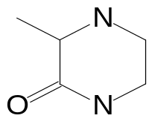
CH₃CH(OH)CN
H⁺
reflux
A
B
SOCl₂
reflux
C
D
CH₃CH₂OH
ethanol
step 1
step 2
(i) Ethanol can undergo a two–step synthesis to form compound A. Suggest suitable reagents and conditions for this two–step synthesis.

Step 1: .………………………………………………………………………………….

Step 2: .………………………………………………………………………………….
(ii) Draw the structural formula of compound C.

(iii) Suggest reagents and conditions required to convert C to D.

………………………………………………………………………………………………...
[4]

[Total: 15]

4(a) Suggest how the following compounds could be distinguished from each other by chemical tests. The distinguishing of some of these pairs may rely on a preliminary breaking–up of the compounds, and subsequent testing of the reaction products.

For each test, state the reagents and conditions you would use, and the observations you would make with each compound undergoing the test.

(i) 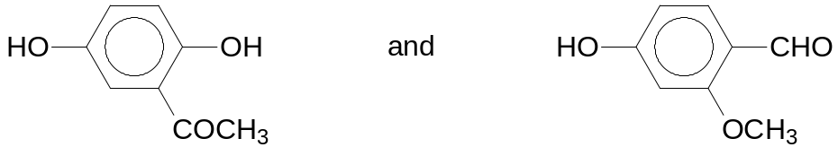

(ii) 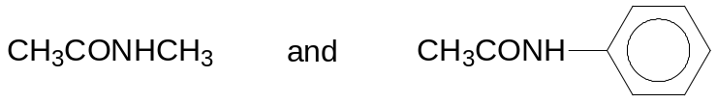

[5]
(b) Sulfur dichloride oxide (thionyl chloride), SOCl₂, is a useful reagent in organic synthesis, converting –OH groups into –Cl groups.

R–OH + SOCl₂ → R–Cl + HCl + SO₂

(i) Draw a dot–and–cross diagram of SOCl₂.

(ii) Suggest the size of the bond angle around the sulfur atom in SOCl₂.

…………………………………..

(iii) Suggest the equation for the reaction of SOCl₂ with water.

………………………………………………………………………………………………..

(iv) Methanol, CH₃OH, and thionyl chloride, SOCl₂, differ in their boiling points.

compound | boiling point / ºC
CH₃OH | 65
SOCl₂ | 75

Account for the difference in the boiling points of these two compounds in terms of relevant intermolecular forces.

………………………………………………………………………………………………..

………………………………………………………………………………………………..

………………………………………………………………………………………………..

………………………………………………………………………………………………..

………………………………………………………………………………………………..

………………………………………………………………………………………………..
[5]

(c) The solubility product of silver chloride is 1.8 x 10^{–10} mol² dm^{–6}.

(i) Calculate the maximum mass of silver chloride that could dissolve in 300 cm³ of 5.0 x 10^{–3} mol dm^{–3} silver nitrate without the formation of any precipitate.

(ii) The concentration of chloride ions from silver chloride in (c)(i) is less than the square root of the K_{sp} value of silver chloride. Explain why this is so.

………………………………………………………………………………………………..

………………………………………………………………………………………………..

………………………………………………………………………………………………..

(iii) Suggest why when aqueous sodium thiosulfate was added to the resulting solution in (c)(i), more silver chloride was able to dissolve.

………………………………………………………………………………………………..

………………………………………………………………………………………………..

………………………………………………………………………………………………..

………………………………………………………………………………………………..
[5]

[Total: 15]

5(a) An organic compound X contains by mass, 63.2% carbon, 8.7% hydrogen, and 28.1% oxygen. On treatment with sodium hydrogencarbonate solution, it liberates carbon dioxide. It also undergoes an addition reaction with bromine in a 1:1 molar ratio whereby 1.50 g of the compound reacts with 2.11 g of bromine.

(i) Calculate the empirical formula of X.

(ii) Calculate the relative molecular mass of X.

(iii) Determine the molecular formula of X.

(iv) X is optically active and undergoes catalytic hydrogenation to form a product which is optically inactive.

Suggest a possible structure for compound X. Draw its optical isomers.

[5]
(b) The acidities of CH₃CO₂H, C₆H₅OH and CH₃CH₂OH are different.

(i) Explain the relative acidities of CH₃CO₂H, C₆H₅OH and CH₃CH₂OH in terms of their structures.

………………………………………………………………………………………………...

………………………………………………………………………………………………...

………………………………………………………………………………………………...

………………………………………………………………………………………………...

………………………………………………………………………………………………...

………………………………………………………………………………………………...

(ii) Hence or otherwise, arrange in decreasing order of pK_{b} values of their conjugate bases.

………………………………………………………………………………………………...

(iii) Given that a saturated aqueous solution of C₆H₅OH has a pH of 5.0 and a pK_{a} of 9.95. What is the solubility of C₆H₅OH in mol dm^{–3}?

[6]

(c) The following apparatus is used to compare the rates of hydrolysis of compounds A, B and C below.

C₆H₅CH₂Br | C₆H₅COCl | C₆H₅I
A | B | C
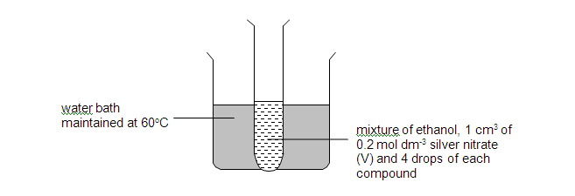
The beaker is placed on a piece of white paper on which a black cross has been marked. The time taken for the contents of the test tube to mask the black cross is measured. The results on three separate test tubes are given below.

Tube 1: black cross always clear
Tube 2: 10 s
Tube 3: 1 s

(i) Match each of the letters A, B and C with the test tube which most closely corresponds to its behaviour.

 | Tube 1 | Tube 2 | Tube 3
Compound

(ii) Briefly explain your answer.

………………………………………………………………………………………………...

………………………………………………………………………………………………...

………………………………………………………………………………………………...

………………………………………………………………………………………………...

………………………………………………………………………………………………...

………………………………………………………………………………………………...

(iii) Explain how the time taken to mask the black cross would be affected if compound A is replaced with C₆H₅CH₂Cl.

………………………………………………………………………………………………...

………………………………………………………………………………………………...

………………………………………………………………………………………………...
[4]

[Total: 15]

